KNN CLASSIFICATION FOR ZOO DATA:

=>The distance metric is used to calculate its nearest neighbors (Euclidean, Manhattan).

=>Can solve classification (by determining the majority class of nearest neighbors) and regression problems (by determining the means of nearest neighbors).

=>If the majority of the nearest neighbors of the new data point belong to a certain class, the model classifies the new data point to that class.

DATA VISUALIZATION:

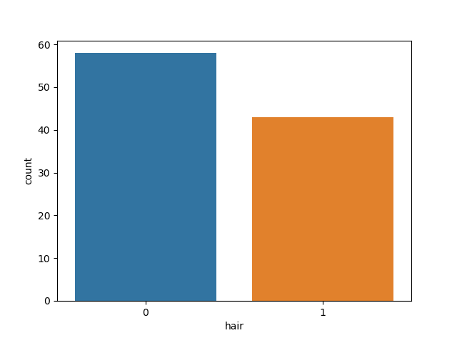

**zoo.info() :**

hair 101 non-null int64

feathers 101 non-null int64

eggs 101 non-null int64

milk 101 non-null int64

airborne 101 non-null int64

aquatic 101 non-null int64

predator 101 non-null int64

toothed 101 non-null int64

backbone 101 non-null int64

breathes 101 non-null int64

venomous 101 non-null int64

fins 101 non-null int64

legs 101 non-null int64

tail 101 non-null int64

domestic 101 non-null int64

catsize 101 non-null int64

type 101 non-null int64

=>split the data into test and train datasets.

=>prepare the KNN model based on the train and test datasets.

=>we got the accuracy of 96%

=> check the accuracy by applying different k values.

=>by using the we can know the best accuracy value for the k value.

